**How to Install Appium on Windows**

Before proceeding to install Appium Make sure you have installed JDK and Android.

First Download Appium from here [Official Appium Site](http://appium.io/)

Once the file **AppiumForWindows_x.x.x.Zip** is downloaded, please unzip the file.

1.You should see ‘appium-installer.exe’ file in the folder, Click on on the installer



2.Select the language and Click on OK

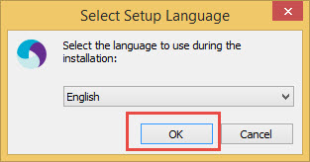

3.In Welcome To Appium Setup screen, Click on Next to continue

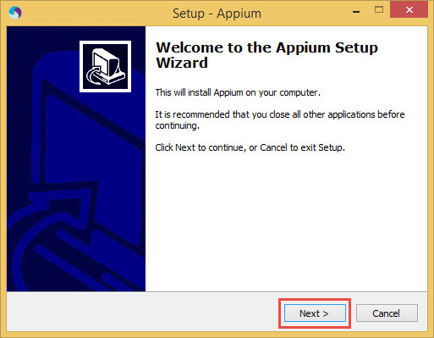

4. Choose folder to install Appium if you wish to change else just click on Next button

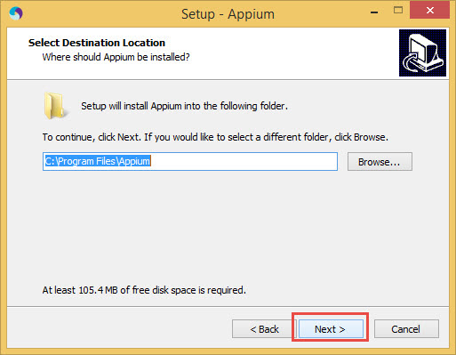

5.Select Start menu folder and Click on Next button

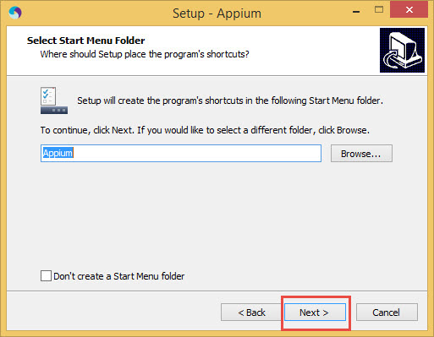

6.To Create Desktop icon, select checkbox and Click on Next button

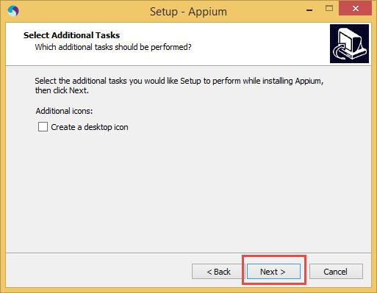

7.Click on ‘Install’ button to install Appium

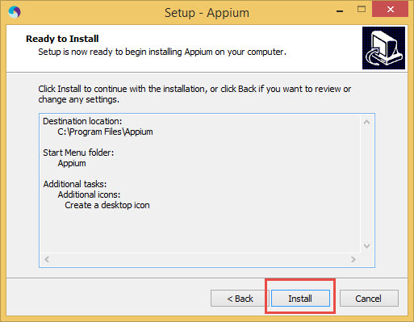

8.Once the installation is done, Click Finish button to Launch Appium

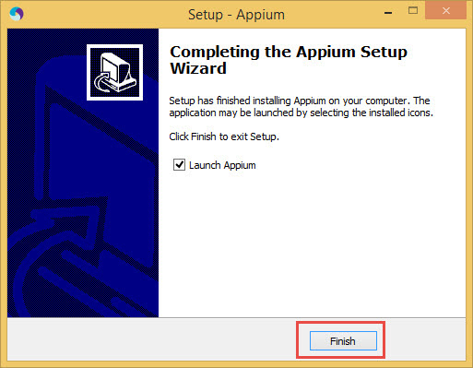

9.This is how the Appium looks like, And to start Appium Server, Click on Play button which will start Appium server.

If you try to execute Appium Test scripts without starting your Appium Server, you will get an exception as 'org.openqa.selenium.remote.UnreachableBrowserException: Could not start a new session. Possible causes are invalid address of the remote server or browser start-up failure.'

So make sure you always start your Appium Server before you start your test execution.

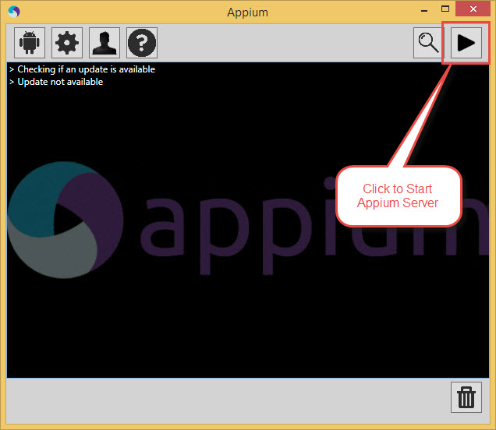

10. Appium will display version details, server address and port number

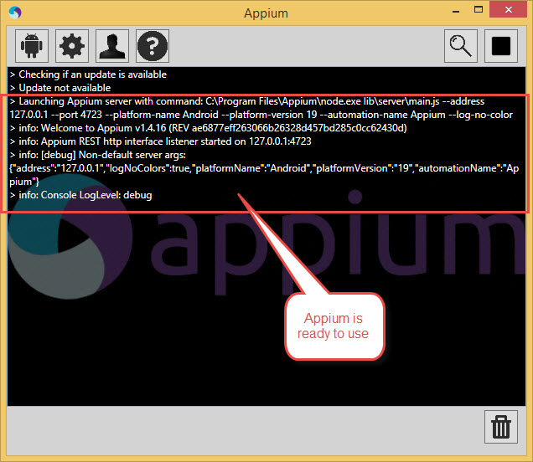

11.You can also view details by Clicking on General Settings button

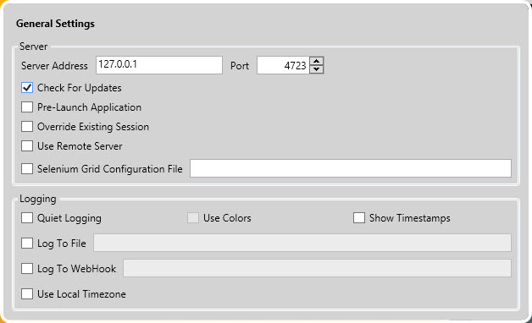

We will now look into the examples on working with Appium in next tutorials.